ITEM | 137 Campbell Hill Road, CHESTER HILL NSW 2162

Site remediation, demolition of existing structures and construction of a shop top housing development containing 100 residential apartments, two ground level retail tenancies, with at-grade and basement car parking and associated civil works

FILE | DA-776/2020 - Bass Hill Ward
ZONING | SP2 Infrastructure and B2 Local Centre
DATE OF LODGEMENT | 4 September 2020
APPLICANT | Waldron Hill Properties Pty Ltd
OWNERS | Waldron Hill Properties Pty Ltd
ESTIMATED VALUE | $30, 644 500.00
AUTHOR | Development Services (Michael Bonnici)

SUMMARY REPORT

This matter is reported to the Sydney South Planning Panel as the application seeks consent for a development for which State Environmental Planning Policy (State and Regional Development) 2011 applies and which the proposal has a capital investment value of more than $30 million in accordance with Section 20 and Schedule 7.

Development Application No. DA-776/2020 proposes site remediation, demolition of existing structures and construction of a shop top housing development containing 100 residential apartments, two ground level retail tenancies, with at-grade and basement car parking and associated civil works.

The development application has been assessed in accordance with the matters for consideration contained in Section 4.15(1) of the Environmental Planning and Assessment Act, 1979 requiring, amongst other things, an assessment against the provisions contained within State Environmental Planning Policy No. 55 - Remediation of Land, State Environmental Planning Policy No 65—Design Quality of Residential Apartment Development and the associated Apartment Design Guide, State Environmental Planning Policy (Vegetation in Non-Rural Areas) 2017, State Environmental Planning Policy (Infrastructure) 2007, State Environmental Planning Policy (Building Sustainability Index: BASIX) 2004, Greater Metropolitan Regional Environmental Plan No 2—Georges River Catchment (a deemed SEPP), Bankstown Local Environmental Plan 2015, Bankstown Development Control Plan 2015 and Draft Consolidated Canterbury Bankstown Local Environmental Plan 2020.

The application was advertised and notified for a period of thirty (30) days, from 30 September to 30 October 2020. No submissions were received.

The application was referred to Sydney Trains and Ausgrid for concurrence in accordance with requirements of State Environmental Planning Policy (Infrastructure) 2007. Ausgrid have provided concurrence with Sydney Trains providing concurrence on a deferred commencement basis.

POLICY IMPACT

The recommendation of this report is that the Development Application be approved. Such a determination would not have any policy implications, as it would uphold the relevant planning and development controls.

FINANCIAL IMPACT

The recommendation of this report is that the Development Application be approved. Such a determination would not have any financial implications.

RECOMMENDATION

It is recommended that the application be approved subject to the conditions included.

DA-776/2020 ASSESSMENT REPORT

SITE & LOCALITY DESCRIPTION

The subject site is known as 137 Campbell Hill Road, Chester Hill. The site is a regular shaped corner allotment that contains a split zoning of SP2 Infrastructure, which comprises approximately 16% of the site area, and B2 Local Centre which comprises approximately 84% of the site area. The site has a primary frontage to Campbell Hill Road of approximately 38.6 metres and a secondary road frontage of 84.82 metres to Waldron Road. The total site area is 3351m².

The site has a gradual fall of approximately 800mm from the north eastern boundary
to the south eastern boundary and a fall of approximately 1.5m from the north western boundary to the south western boundary. The surrounding area is characterised by a mix of commercial and residential development. To the north of the site, on the opposite side of Waldron Road, contains mixed commercial development being both single-storey and two-storey in built form. To the west is a residential flat building across Campbell Hill Road. Immediately adjoining the site to the east are a number of mixed commercial single storey tenancies, while directly to the south of the site is the rail line and to the south east the Chester Hill Railway station.

The site immediately to the west of the development is zoned R4 High Density Residential. The southern part of the subject site and the adjoining allotment to the south are zoned SP2 Infrastructure: Rail Infrastructure Facility. To the north and east, the properties are zoned B2 Local Centre. The site currently contains a disused service station (closed in 2009) and an existing butcher/delicatessen. The site contains a number of easements for drainage, support, electricity supply, right of way and services. Of these easements, the most significant is the easement located on the southern boundary of the property serving a right of way for access to the rear of the adjacent eastern lot. The right of way (located on the southern boundary of the site) is 11 metres wide. The site currently accommodates at grade parking and an access way within the right of way that continues through to the development to the east, providing access to the parking areas located at the south of that property.

As indicated earlier, the subject site has a split zoning being SP2 Infrastructure: Rail Infrastructure Facility and B2 Local Centre. The setback from the southern/rear boundary (SP2 land) to the B2 Local Centre zone within the site is 6 metres, resulting in the area of SP2 land being 543m². The subsequent remaining area of B2 Local Centre zoned land is 2808m². The site located to the east at No. 129 Campbell Hill Road, accommodates the same zoning arrangements. Pursuant to the Bankstown Local Environment Plan 2015, the B2 Local Centre portion of the site has a maximum height control of 26 metres and maximum FSR of 3:1. The resulting SP2 Infrastructure zoned land does not have an applicable height or FSR control applying to it. The BLEP 2015 maps are provided below:

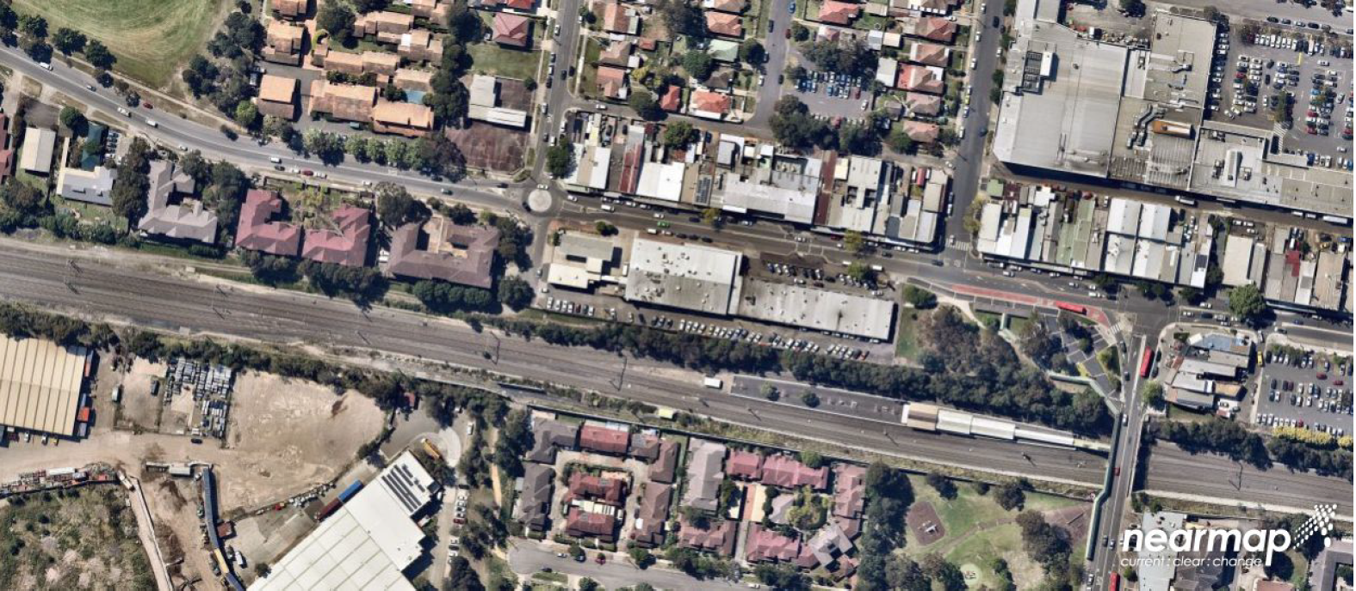
Image 1 - Aerial Image (Nearmap, 2 October 2020)

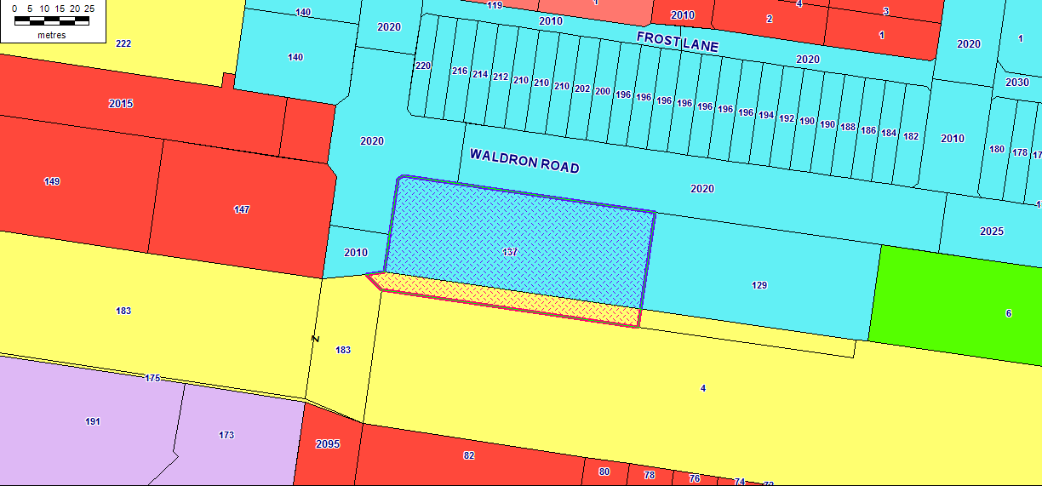
Image 2 – Land Zoning Map

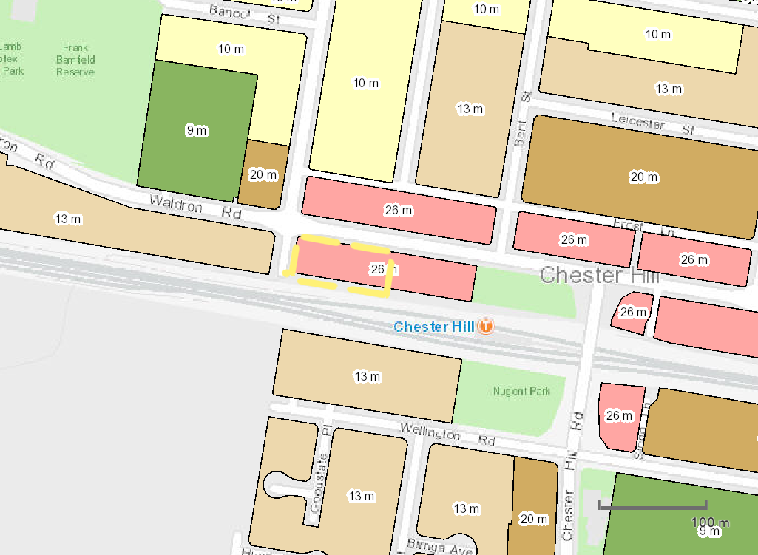
Image 3 - Height of buildings

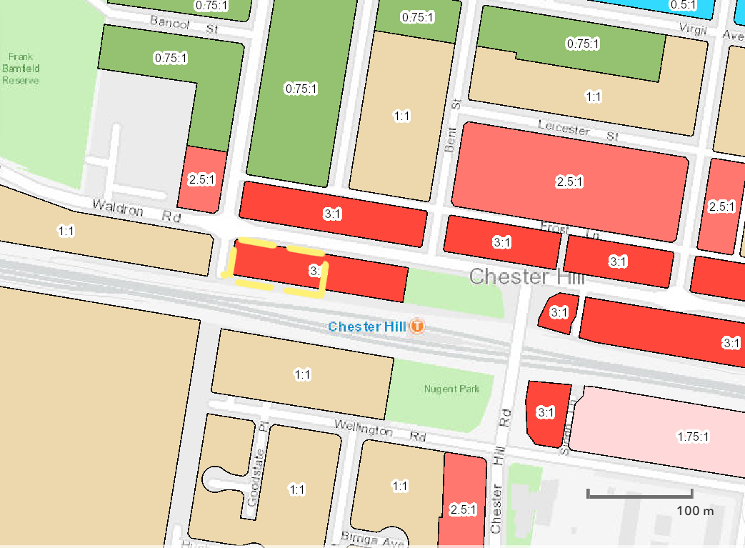
Image 4 - Floor Space Ratio

PROPOSED DEVELOPMENT

The development application proposes site remediation, the demolition of all structures on site, construction of a shop top housing development consisting of 100 residential units, two ground level retail tenancies, at-grade surface and basement car parking, associated civil engineering works and associated landscaping works.

The specifics of the development are as follows:

Floor | Description
Basement Level 2 | 60 parking spaces
Basement Level 1 | 54 parking spaces + Bicycle Racks
Ground Floor | Two retail tenancies: Retail A (167m²), Retail B (255m²)  At grade parking: 33 parking spaces, 3 motorcycle spaces and 2 loading spaces
 | No. of one Bedroom units | No. of two Bedroom units
Level 01 | 4 | 12
Level 02 | 4 | 12
Level 03 | 4 | 12
Level 04 | 4 | 10
Level 05 | 4 | 10
Level 06 | 4 | 10
Level 07 | 4 | 6

The proposal has a ground floor containing at grade car parking, two (2) commercial tenancies, waste services facilities and communal open space. Vehicular access to the two basement levels is located off Campbell Hill Road (within the B2 Local Centre zoned land), with vehicular access to the at grade spaces for commercial development provided through a separate access point (also located within the B2 zoned land).

In addition to the spaces located under the building at grade, the proposal also provides for an additional twenty-eight (28) car parking spaces in the southern portion of the site. These spaces at grade to the south of the proposal (not within the building) are currently located within that part of the site zoned SP2 Infrastructure: Rail Infrastructure Facility. The spaces located within the SP2 zoned land are not relied upon, or required for the proposed development, and are provided in addition to the minimum requirements for parking on the site. Access to these spaces (both existing and proposed) is through a driveway access located within that part of the site zoned B2 which currently exists on site, and the proposed access to these spaces remains unchanged as a result of this application. Should Sydney Trains ever acquire the SP2-zoned portion of the site in the future, the proposal will retain access to the spaces at grade within the building (B2 zoning) as a driveway 5 metres wide would be retained, post-acquisition.

The building design incorporates a mix of materials and finishes including concrete, aluminium pivoting blades, alpolic finishes, glazing and timber cladding soffit.

Statutory Considerations

When determining this application, the relevant matters listed in Section 4.15(1) of the Environmental Planning and Assessment Act 1979 must be considered. In this regard, the following environmental planning instruments, development control plans, codes and policies are relevant:

- State Environmental Planning Policy 55 – Remediation of Land
- State Environmental Planning Policy 65 – Design Quality of Residential Apartment Development
- State Environmental Planning Policy (Vegetation in Non-Rural Areas) 2017
- State Environmental Planning Policy (Infrastructure) 2007
- State Environmental Planning Policy (Building Sustainability Index: BASIX) 2004
- Bankstown Local Environmental Plan 2015
- Bankstown Development Control Plan 2015
- Bankstown Development Contributions Plan 2019
- Draft Consolidated Canterbury Bankstown Local Environmental Plan 2020

SECTION 4.15 ASSESSMENT

The proposed development has been assessed pursuant to section 4.15 of the Environmental Planning and Assessment Act, 1979.

State Environmental Planning Policy (State and Regional Development) 2011

A regional panel may exercise the consent authority functions of Council for the determination of applications included in Schedule 7 of State Environmental Planning Policy (State and Regional Development) 2011. Schedule 7 includes ‘general development over $30 million’. The proposed capital investment value of $30,644,500 falls within this category. Accordingly, the application is reported to the Sydney South Planning Panel for determination.

Environmental planning instruments [section 4.15(1)(a)(i)]

State Environmental Planning Policy 55 – Remediation of Land

Clause 7 of State Environmental Planning Policy 55 – Remediation of Land (SEPP 55) requires Council to consider whether the land is contaminated prior to granting consent to the carrying out of any development on that land. Should the land be contaminated, Council must be satisfied that the land is suitable in a contaminated state for the proposed use. If the land requires remediation to be undertaken to make it suitable for the proposed use, we must be satisfied that the land will be remediated before the land is used for that purpose.

The site has a history of accommodating various commercial land uses including a service station and as such a Detailed Site Investigation (DSI) was submitted with application which recommended the need for a remedial action plan. A subsequent Remediation Action Plan (RAP) was prepared and submitted, based on the recommendations of the DSI. The report notes the encounter of contaminates in site samples and recommends strategies to undertake the required remediation. The proposal has been considered as category 1 remediation in accordance with the provisions of Clause 13 of SEPP 55.

Council’s environmental health officers have reviewed the reports submitted and are satisfied that the site will be suitable for the proposed use. It is therefore considered that the consent authority is satisfied that the development site can be made suitable for the proposed development, in accordance with Clause 7 of SEPP 55.

State Environmental Planning Policy (Infrastructure) 2007

Transport for NSW (Sydney Trains)
The proposed development involves works directly adjacent to the railway corridor within the vicinity of the Chester Hill Railway Station. The proposal incorporates works that involve penetration of the ground to at least 2m below ground level within the vicinity of a rail corridor thereby requiring concurrence from Sydney Trains as specified in Section 86 of State Environmental Planning Policy (Infrastructure) 2007 (SEPP (Infrastructure).
Sydney Trains assessed the plans lodged with the application and provided comments to Council on 8 October 2020. Sydney Trains requested additional information and plans as well as amendments to ensure works would not occur within the railway corridor.
The provided information has enabled Sydney Trains to provide concurrence on a deferred commencement basis. It is noted that deferred commencement is limited to a 12-month period for activation and conditions to be satisfied prior to the activation of the consent.
Ausgrid
The proposed development involves works within 5m of overhead lines. In accordance with clause 45 of SEPP Infrastructure, a referral to the electricity supply authority for the area was required.

Ausgrid have assessed the plans lodged in support of the application, and advised on 19 October 2020 that they consent to the proposed development subject to managing any impacts on existing electricity network assets and the relevant Ausgrid Network Standards, Safe Work NSW Codes of Practice for construction works near existing electrical assets.

Ausgrid’s concurrence has been provided, notwithstanding that they did not recommend the imposition of any conditions of consent.

State Environmental Planning Policy (Building Sustainability Index: BASIX) 2004

In accordance with State Environmental Planning Policy (Building Sustainability Index: BASIX) 2004, a BASIX Certificate accompanied this application. The Certificate makes a number of energy/resource commitments relating to water, energy and thermal comfort. The relevant commitments indicated on the BASIX Certificate have been shown on the plans in order to satisfy objectives of the SEPP.

State Environmental Planning Policy (Vegetation in Non-Rural Areas) 2017

The proposed development and vegetation removal on the site is considered to be consistent with the aims and requirements of Section 3 & 10 of State Environmental Planning Policy (Vegetation in Non-Rural Areas) 2017. The site only contains insignificant vegetation with removal of two trees proposed. The site is devoid of any vegetation worthy of being retained with Council raising no objection to the removal of the two existing trees that occupy the site. Significant replanting’s are shown, which are considered to be of a greater landscaped amenity than of that to which is existing.

Greater Metropolitan Regional Environmental Plan No. 2 – Georges River Catchment

The site is located within land identified as being affected by Greater Metropolitan Regional Environmental Plan No. 2 – Georges River Catchment, being a deemed SEPP under Clause 120 of Schedule 6 of the EP&A Act, 1979. The GMREP 2 contains a series of general and specific planning principles which are to be taken into consideration in the determination of development applications. An assessment of the proposal indicates that the development is generally consistent with the aims and objectives of the plan, as well as the planning principles as set out in Clause 8 of the GMREP 2.

State Environmental Planning Policy 65 - Design Quality of Residential Apartment Development

This policy applies to residential apartment development and is required to be considered when assessing this application. Residential apartment development is defined under State Environmental Planning Policy 65 – Design Quality of Residential Apartment Development (SEPP 65) as development for the purpose of a residential flat building, shop top housing or mixed-use development with a residential accommodation component. The development must consist of the erection of a new building, the conversion of an existing building or the substantial redevelopment or refurbishment of an existing building. The building must also be at least 3 or more storeys and contain at least 4 or more dwellings. Residential apartment development does not include boarding houses or serviced apartments.

SEPP 65 aims to improve the design quality of residential apartment development across NSW and provides an assessment framework, the Apartment Design Guide (ADG), for assessing ‘good design’. Clause 50(1A) of the Environmental Planning and Assessment Regulation 2000 requires the submission of a design verification statement from a qualified designer (registered architect) at lodgement of the development application that addresses the design quality principles contained in SEPP 65 and demonstrates how the objectives in Parts 3 and 4 of the ADG have been achieved. It is noted that a design verification statement was submitted with the application, signed by Chris Tsioulos, registered architect no. 5143.

Apartment Design Guide

The development has been considered against the various provisions of the Apartment Design Guide in accordance with Clause 28(2)(c) of SEPP 65.

Part 3 –Siting of the Development
Objective | Design Guidance | Proposed | (Y/N)
3B-1  Orientation - Streetscape  Building types and layouts respond to the streetscape and  site while optimising solar access within the development | Buildings along the street frontage define the street, by facing it and incorporating direct access from the street | The development suitably addresses both Waldron Road and Campbell Hill Road. Vehicular access is ideally proposed off Campbell Hill Road. | Y
3B-2 Orientation – Overshadowing  Overshadowing of neighbouring properties is minimised during mid-winter | Living areas, private open space and communal open space should receive solar access in accordance with sections 3D Communal and public open space and 4A Solar and daylight access | Sufficient solar access is achieved as required by sections 3D and 4A of the ADG as demonstrated in this table | Y
 | Solar access to living rooms, balconies and private open spaces of neighbours should be considered | The neighbouring property to the west (147 Waldron Road, Chester Hill) maintains direct sunlight between 9am – 3pm at the mid-winter solstice.  The multi-dwelling housing development at 82 Wellington Road, Chester Hill is also largely unaffected with only partial overshadowing occurring at 9am to two northern units | Y
 | A minimum of 4 hours of solar access should be retained to solar collectors on neighbouring buildings | One of the northern multi dwelling units at 82 Wellington Road, Chester Hill has solar panels, yet they maintain the minimum of 4 hours direct sunlight at the mid-winter solstice. | Y
3C-1  Transitions  Transition between private and public domain is achieved without compromising safety and security | Terraces, balconies and courtyard apartments should have direct street entry, where appropriate | No courtyards provided along the street. Commercial floor space only on ground level | Y
 | Changes in level between private terraces, front gardens and dwelling entries above the street level provide surveillance and improve visual privacy for ground level dwellings | No ground floor terraces or dwelling entries are provided directly off the street | Y
 | Upper level balconies and windows should overlook the public domain | Upper level balconies and living room windows directly overlook the public domain | Y
 | Front fences and walls along street frontages should use visually permeable materials and treatments. The height of solid fences or walls should be limited to 1m | No front fences are proposed | Y
3-D-1 Communal Open Space  An adequate area of communal open space is provided to  enhance residential amenity and to provide opportunities for  landscaping | Design Criteria  Communal open space has a minimum area equal to 25% of the site  Developments achieve a minimum of 50% direct sunlight to the principal usable part of the communal open space for a minimum of 2 hours between 9 am and 3 pm on 21 June (mid-winter) | 998.5sqm or 29.7% of the site area is provided as communal open space  The COS is proposed on the first floor level and is north facing. Direct sunlight is achieved to the principal part of the COS for a minimum of 2 hours between 9am and 3pm on 21 June (mid winter) | Y
 | Communal open space should have a minimum dimension of 3m, and larger developments should consider greater dimensions | Minimum dimension of 3m for the open space is provided | Y
 | Communal open space should be co-located with deep soil areas | Communal open space is not located in deep soil zones due to the ground floor retail component. Communal open space is still deemed to have the desired effect of providing seating areas integrated into the green spaces | Y
 | Direct, equitable access should be provided to communal open space areas from common circulation areas, entries and lobbies | It is considered that there is equitable access to the open space | Y
3E-1 Deep Soil Zones  Deep soil zones provide areas on the site that allow for  and support healthy plant and tree growth. They improve  residential amenity and promote management of water and  air quality | Design Criteria  Deep soil zones are to meet the following minimum  requirements:  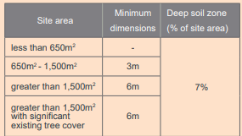 | Site area: 3351m²  7% of 3351m² = 234.57m²  216sqm of deep soil zone provided = 6% of the site area (measured at less than 6m dimension) | N
 | Achieving the design criteria may not be possible on some sites including where:  • the location and building typology have limited or no space for deep soil at ground level (e.g. central business  district, constrained sites, high density areas, or in centres)  • there is 100% site coverage or non-residential uses at ground floor level  Where a proposal does not achieve deep soil requirements, acceptable stormwater management should be achieved and alternative forms of planting provided such as on structure | Given the site is located within the Chester Hill town centre and its proximity to the station, it is considered that the ground floor commercial component suitably engages with the street frontage and promotes pedestrian activity / connectivity with the town centre. As such, a minor variation to the design criteria is supported in this instance. | Y
3F-1 Building Separation  Adequate building separation distances are shared equitably  between neighbouring sites, to achieve reasonable levels of  external and internal visual privacy | Design Criteria  Separation between windows and balconies is provided to ensure visual privacy is achieved. Minimum required separation distances from buildings to the side and rear boundaries are as  follows:  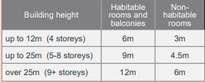 | 6.8m to the eastern boundary – below the minimum  11m to the rear southern boundary – compliant  0m to the western boundary – below the minimum  Notwithstanding the non-compliance raised above, Council is receptive given it has been supported previously and is receptive to the site constraints being numerous easements and restrictions as well as the adjoining eastern lot (No. 129 Waldron Road) contains single storey commercial tenancies. The site is afforded the same planning controls in respect to zoning, floor space ratio and height of buildings.  It is considered that the design of the development put forth can be considered as satisfactory in its surroundings, given the adjoining developments and the minor nature of the departure. It is not considered that the visual privacy impacts are likely for the existing adjoining developments, being that they are of single storey commercial premises. The minor variation to the side setback is not likely to cause any significant impact and it is considered that any future development would not be hindered by the variation as proposed.  Despite the numerical non-compliances, sufficient separation and visual privacy is achieved to each boundary due to the use of architectural treatments, floor plan layout and/or through recommended conditions of consent and is therefore considered worthy of support. | N
3F-2 Visual Privacy  Site and building design elements increase privacy without  compromising access to light and air and balance outlook  and views from habitable rooms and private open space | Communal open space, common areas and access paths should be separated from private open space and windows  to apartments, particularly habitable room windows. | Suitable measures have been incorporated into the design such that at the interface of private and communal areas, adequate privacy and amenity is preserved and retained | Y
3G-1 Building entries  Building entries and pedestrian access connects to and  addresses the public domain | Multiple entries (including communal building entries and individual ground floor entries) should be provided to activate the street edge | Open entry ways provided via the Public domain on Waldron Road, to the northern entry doors. | Y
 | Building entries should be clearly identifiable and communal entries should be clearly distinguishable from private entries | Communal entry is identifiable and is not easily confused with private entries | Y
3G-2 Entry accessibility  Access, entries and pathways are accessible and easy to  identify | Building access areas including lift lobbies, stairwells and hallways should be clearly visible from the public domain and communal spaces | Lift lobby is clearly identifiable from the entry points, as is the main entrance to the building | Y
3H-1 Vehicle Access  Vehicle access points are designed and located to achieve  safety, minimise conflicts between pedestrians and vehicles  and create high quality streetscapes | Car park access should be integrated with the building’s overall facade. Design solutions may include:  • the materials and colour palette to minimise visibility from the street  • security doors or gates at entries that minimise voids in the facade  • where doors are not provided, the visible interior reflects the facade design and the building services, pipes and ducts are concealed | Access to the basement deemed to be integrated with the building’s overall façade. Proposed access off Campbell Hill Road avoids disruption to the Waldron Road streetscape. | Y
 | Car park entry and access should be located on secondary streets or lanes where available | Car park entry is provided off Campbell Hill Road (considered to function as the secondary street) | Y
 | The need for large vehicles to enter or turn around within the site should be avoided | Large vehicles, particularly Council waste trucks have been shown to satisfactorily enter / exit Campbell Hill Road in a forward direction in accordance with the requirements of AS2890.1 | Y
 | Garbage collection, loading and servicing areas are screened | Garbage room contained within the building and is not visible from the public domain | Y
 | Clear sight lines should be provided at pedestrian and vehicle crossings | The Ground Floor Plan (Dwg DA2.00 Issue G dated 29/07/2021) shows the sight triangle on both the northern / southern entry side of the driveway | Y
3J-1 Proximity to public transport  Car parking is provided based on proximity to public transport  in metropolitan Sydney and centres in regional areas | Design Criteria  For development in the following locations:  • on sites that are within 800 metres of a railway station or light rail stop in the Sydney Metropolitan Area; or  • on land zoned, and sites within 400 metres of land zoned, B3 Commercial Core, B4 Mixed Use or equivalent in a nominated regional centre the minimum car parking requirement for residents and visitors is set out in the Guide to Traffic Generating Developments, or the car parking requirement prescribed by the relevant council, whichever is less  The car parking needs for a development must be provided off street | The site is within 800m of Chester Hill Station hence the Guide to Traffic Generating Developments can be relied on.  64.8 spaces required for 2 bed units.  16.8 spaces required for 1 bed units.  20 space required for visitors.  1 space required for a delivery and service space  10.5 spaces required for commercial tenancies  Total of 114 car spaces required. 119 provided.  Basement 1 – 54 spaces  Basement 2 – 60 spaces  At grade (not within the SP2 zoned land) – 5 spaces  Total – 119 spaces  Parking provided on the SP2 zoned land has not been included in the calculations | Y
3J-5 On-grade parking  Visual and environmental impacts of on-grade car parking  are minimised | On-grade car parking should be avoided | On-grade parking proposed in the SP2 zoned portion of the site not calculated towards to main car parking amount. Considered acceptable given the split zoning. | Y
Part 4 – Designing the building
4A-1 Solar access | Design Criteria  Living rooms and private open spaces of at least 70% of apartments in a building receive a minimum of 2 hours direct sunlight between 9 am and 3 pm at mid-winter in the Sydney Metropolitan Area and in the Newcastle and Wollongong local government areas  A maximum of 15% of apartments in a building receive no direct sunlight between 9 am and 3 pm at mid-winter | 70% = 70  (80 units provided with a minimum of 2 hours direct sunlight)  15% = 15  (12 units receive no direct sunlight) | Y
4A-2 Daylight access  Daylight access is maximised where sunlight is limited | Courtyards, skylights and high-level windows (with sills of 1,500mm or greater) are used only as a secondary light source in habitable rooms | Highlight windows and the like are only relied on as a secondary source of light and are not the primary sources of light | Y
 | Where courtyards are used:  • use is restricted to kitchens, bathrooms and service areas  • building services are concealed with appropriate detailing and materials to visible walls  • courtyards are fully open to the sky  • access is provided to the light well from a communal area for cleaning and maintenance  • acoustic privacy, fire safety and minimum privacy separation distances (see section 3F Visual privacy) are achieved | Building services are concealed within the building design.  Courtyard is open to the sky  Access to the courtyard is available from the COS | Y
4B-3 Cross Ventilation  The number of apartments with natural cross ventilation is  maximised to create a comfortable indoor environment for  residents | Design Criteria  At least 60% of apartments are naturally cross ventilated in the first nine storeys of the building. Apartments at ten storeys or greater are deemed to be cross ventilated only if any enclosure of the balconies at these levels allows adequate natural ventilation and cannot be fully enclosed  Overall depth of a cross-over or cross-through apartment does not exceed 18m, measured glass line to glass line | Floor Cross Ventilated Units  1 8  2 8  3 8  4 8  5 12  6 12  7 10  Total 66  Total Units = 100  60% = 60 apartments  Compliant apartments: 66 | Y
4C-1 Ceiling heights  Ceiling height achieves sufficient natural ventilation and  daylight access | Design Criteria  Measured from finished floor level to finished ceiling level, minimum ceiling heights are:  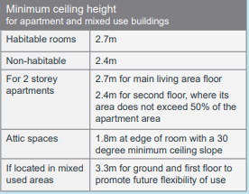 | Ground  Level 1 2.8m  Level 2 2.8m  Level 3 2.8m  Level 4 2.8m  Level 5 2.8m  Level 6 2.8m  Level 7 2.8m | Y
4D-1 Apartment layout  The layout of rooms within an apartment is functional, well organised and provides a high standard of amenity | Design criteria  Apartments are required to have the following minimum internal areas:  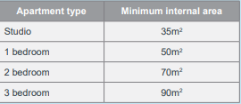  The minimum internal areas include only one bathroom. Additional bathrooms increase the minimum internal area by 5m² each | All Units meet the minimum internal area requirements, all providing a bathroom and an external window with the minimum glass area. | Y
4D-2 Environmental performance | Design Criteria  In open plan layouts (where the living, dining and kitchen are combined) the maximum habitable room depth is 8m from a window | All habitable rooms are limited to a maximum depth of 8m from a window | Y
4D-3 apartment layout | Design Criteria  Master bedrooms have a minimum area of 10m² and other bedrooms 9m² (excluding wardrobe space)  Bedrooms have a minimum dimension of 3m (excluding wardrobe space)  Living rooms or combined living/dining rooms have a minimum width of:  • 3.6m for studio and 1 bedroom apartments  • 4m for 2 and 3 bedroom apartments | All master beds min. 10m² excl. wardrobe space  All other bedrooms of units have min. 9m² excluding wardrobe space  All bedrooms have min. 3m dimension  All living areas for 1 bed units have min. 3.6m  All living areas for 2 bed units have min 4m width | Y
4E-1 POS  Apartments provide appropriately sized private open space  and balconies to enhance residential amenity | Design criteria  All apartments are required to have primary balconies as follows:  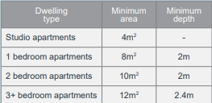  The minimum balcony depth to be counted as contributing to the balcony area is 1m  For apartments at ground level or on a podium or similar structure, a private open space is provided instead of a balcony. It must have a minimum area of 15m2 and a minimum depth of 3m | 1 bed units have min. 8m² in total with a min. depth of 2m  2 bed units have min. 10m² with min. 2m depth  No ground level units proposed | Y
4E-2 Location of POS  Primary private open space and balconies are appropriately  located to enhance liveability for residents | Primary open space and balconies should be located adjacent to the living room, dining room or kitchen to extend the living space | POS / balconies are an extension of internal living areas | Y
 | Primary open space and balconies should be orientated with the longer side facing outwards or be open to the sky to optimise daylight access into adjacent rooms | This has been achieved with this development | Y
4F-1 Common circulation space  Common circulation spaces achieve good amenity and properly service the number of apartments | Design criteria  The maximum number of apartments off a circulation core on a single level is eight | Two circulation cores (four lifts total) provided which each service a maximum of eight units | Y
4G-1 Storage  Adequate, well designed storage is provided in each apartment | Design Criteria  In addition to storage in kitchens, bathrooms and bedrooms, the following storage is provided:  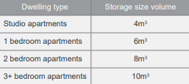  At least 50% of the required storage is to be located within the apartment | All units comply with the provision of storage, with at least 50% of the required storage area being provided within the apartments. | Y
4K-1 Aapartment mix  A range of apartment types and sizes is provided to cater for  different household types now and into the future | The apartment mix is appropriate, taking into consideration:  • the distance to public transport, employment and education centres  • the current market demands and projected future demographic trends  • the demand for social and affordable housing  • different cultural and socioeconomic groups | The development provides for an appropriate level of housing choice in accordance with the ADG. | Y
4M-1 Building façade  Building facades provide visual interest along the street while respecting the character of the local area | Design solutions for front building facades may include:  • a composition of varied building elements  • a defined base, middle and top of buildings  • revealing and concealing certain elements  • changes in texture, material, detail and colour to modify the prominence of elements | Varied building materials – render & cladding, glass.  The streetscape design and the external finishes proposed are representative of more modern forms of architecture found throughout the area. It is considered that the development will result in a positive contribution to the streetscape and identity of the business zone. | Y
4S-1 Mixed use | Mixed use development includes multiple uses in one building. In apartment buildings this is commonly achieved vertically with different uses stacked above one another. A vertical mix of uses is more likely to increase activity through the days and night which in turn improves passive surveillance of the public domain.  Mixed use developments are provided in appropriate locations and provide active street frontages that encourage pedestrian movement  Mixed use development should be concentrated around public transport and centres  Residential entries and services to be separated to commercial entries.  Concealment opportunities are avoided  Landscaped communal open space areas should be provided at podium or roof levels. | The development is a mixed-use development containing residential units and commercial tenancies.  The development provides an active frontage with a defined commercial edge to ground floor. The façade provides clear delineation of the residential entry points at the pedestrian level and incorporates activation of the public domain during the day and night with passive surveillance opportunities in the residential design above.  The residential areas and the commercial entries and services are separate and concealment opportunities are avoided. The communal open space areas provide substantial areas dedicated to landscaping. | Y
4W-1 Waste storage  Waste storage facilities are designed to minimise impacts on the streetscape, building entry and amenity of residents | Adequately sized storage areas for rubbish bins should be located discreetly away from the front of the development or in the basement car park | An adequately sized waste storage area has been provided within the building | Y
 | Waste and recycling storage areas should be well ventilated | Area is well ventilated with multiple openings | Y
4W-2 Domestic waste  Domestic waste is minimised by providing safe and convenient source separation and recycling | All dwellings should have a waste and recycling cupboard or temporary storage area of sufficient size to hold two days worth of waste and recycling | Waste storage within units considered to be acceptable | Y

Bankstown Local Environmental Plan 2015

This site is zoned B2 Local Centre and SP2 Infrastructure under the Bankstown Local Environmental Plan 2015 (BLEP 2015). The controls applicable to this application are discussed below.

Clauses 2.3 of BLEP 2015 states that the consent authority must have regard to the objectives for development in a zone when determining a development application in respect of land within the zone.

The objectives of the B2 Local Centre Zone are as follows:

- To provide a range of retail, business, entertainment and community uses that serve the needs of people who live in, work in and visit the local area.
- To encourage employment opportunities in accessible locations.
- To maximise public transport patronage and encourage walking and cycling.
- To provide for certain residential uses that are compatible with the mix of uses in local centres.

The proposed development meets the objectives of the B2 zone as it provides for a mix of land uses in a local centre which encourages employment opportunities and maximises public transport patronage. The design comprises a mix of residential types through incorporating one and two bedroom apartments to contribute to the needs of the community.

The objectives of the SP2 Infrastructure Zone are as follows:

- To provide for infrastructure and related uses.
- To prevent development that is not compatible with or that may detract from the provision of infrastructure.

The proposed development within the SP2 Infrastructure Zone is considered to meet the objectives by maintaining the existing parking spaces which can be utilised at any point by Transport for NSW to provide for infrastructure and related uses.

Provision/ Standard | Requirement | Proposal | Complies
Part 2 Permitted or Prohibited Development
2.1-2.3 Zoning | B2 Local Centre  SP2 Infrastructure | The development is permissible with consent in a B2 Local Centre Zone. It is noted that no component of the development relies on the southern part of the site that is zoned SP2. | Y
2.7 Demolition requires development consent | The demolition of a building or work may be carried out only with development consent. | The applicant seeks approval to demolish all existing on-site structures | Y
Part 4 Principal Development Standards
4.1B Minimum lot sizes and special provisions for certain dwellings | Minimum area of the lot: 1500m²  Minimum width of the lot (as measured at the front building line): 30m | 3351m²  38.6m | Y
4.3 Height of Buildings | Max. height of 26m | 26m | Y
4.4 Floor Space Ratio | Max. FSR of 3:1 | 3:1 | Y
4.5 Calculation of floor space ratio and site area | Land on which the proposed development is prohibited must be excluded from the site area | It is noted that the floor space ratio calculation excludes the site area apportioned from the SP2 Infrastructure zoned land. | Y
Part 6 Local Provisions
6.2 Earthworks | Before granting consent to development including earthworks, the following must be considered:  - drainage patterns and soil stability  (b) the likely future use or redevelopment of the land,  (c) quality of the fill or the soil to be excavated, or both,  (d) effect of development on existing and likely amenity of adjoining properties,  (e) the source of any fill material and the destination of any excavated material,  (f) the likelihood of disturbing relics,  (g) the potential for adverse impacts on, any waterway, drinking water catchment or environmentally sensitive area,  (h) appropriate measures proposed to avoid, minimise or mitigate the impacts of the development. | Extensive earthworks are proposed in association with this development primarily to accommodate basement car parking. Subject to the applicant satisfying deferred commencement issues raised by Sydney Trains, no objection is raised to the extent of the excavation being proposed | Y
6.3 Flood Planning | This clause applies to land at or below the flood planning level.  Development consent must not be granted to development on land to which this clause applies unless the consent authority is satisfied that the development:  (a) is compatible with the flood hazard of the land, and  (b) will not significantly adversely affect flood behaviour resulting in detrimental increases in the potential flood affectation of other development or properties, and  (c) incorporates appropriate measures to manage risk to life from flood, and  (d) will not significantly adversely affect the environment or cause avoidable erosion, siltation, destruction of riparian vegetation or a reduction in the stability of riverbanks or watercourses, and  (e) is not likely to result in unsustainable social and economic costs to the community as a consequence of flooding. | The site is identified as being impacted by the Villawood Medium Flood C12 affectation requiring the attainment of a Council Stormwater Systems Report. Council’s stormwater engineers have undertaken an assessment of the applicant’s hydraulic plans. Their assessment revealed that the proposal suitably responds to the flood affectation and will not significantly affect the flood behaviour for the adjoining developments. | Y

Proposed Environmental Planning Instruments [section 4.15(1)(a)(ii)]

The following draft environmental planning instrument applies to this development.

Draft Canterbury Bankstown Consolidated Local Environmental Plan 2020

The Draft Canterbury Bankstown Local Environmental Plan 2020 (CBLEP 2020) applies to the subject site. Draft CBLEP 2020 has been publicly exhibited and was adopted by the Canterbury Bankstown Local Planning Panel on 30 June 2020 and is now being considered by the Department of Planning Industry and Environment for finalisation. While the draft instrument proposes the introduction of some additional provisions, in the most part, Draft CBLEP 2020 provides for an administrative conversion of both the BLEP 2015 and CLEP 2012 into a combined document under the Standard Instrument LEP template.

With respect to the proposed development, the proposal remains consistent with the aims and objectives of the draft instrument. The proposed development is not inconsistent with the draft provisions.

Development control plans [section 4.15(1)(a)(iii)]

Bankstown Development Control Plan 2015

The following table provides a summary of the development application against the controls contained in Part A1, B2, B5 & B13 of the Bankstown Development Control Plan 2015.

STANDARD | REQUIRED | PART A1, B2, B5 & B13 of BDCP 2015
 |  | PROPOSED | COMPLIANCE
Part A1 - Centres
Height and storeys | Development within the Chester Hill Village Centre and Sefton Small Village Centre must comply with the storey limit that corresponds with the maximum building height shown for the site on the Height of Building Map as follows:  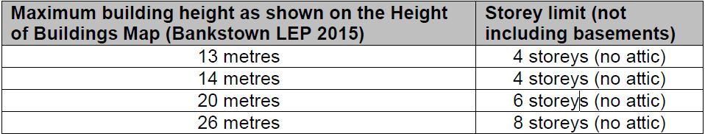 | 26 metres and 8 Storeys | Yes
Primary Setback | The minimum setbacks to the primary road frontage of an allotment within  Zone B2 Local Centre are:  (a) zero setback for the basement level, the first storey (i.e. the ground floor) and second storey; and  (b) 5 metres for the third storey and above. | Ground Floor Commercial approximately 5.8m setback  Residential level 1–7, zero setback is proposed | No, see discussion below
Secondary Setbacks | The minimum setback to the secondary road frontage and the side boundary of an allotment within Zone B2 Local centre is zero setback for all storeys.  Where development is adjacent to residential zoned land, Council may  increase the minimum setback to the secondary road frontage and side boundary. | Ground floor Level (commercial) provides a zero setback to the secondary frontage  Residential level 1 to 7, proposes zero to the north eastern and western corners of the building and 6.845m – 7.145m to the bulk of the building | Yes
Rear setbacks | The minimum setbacks to the rear boundary of an allotment within Zone B2 Local Centre are:  (a) zero setback for the first storey (i.e. the ground floor) and second storey  where the site adjoins a rear lane; or  (b) 3 metres for the first storey (i.e. the ground floor) and second storey  where the site does not adjoin a rear lane; and  (c) 3 metres for the third storey and above. | - 11 metres proposed to all levels | Yes
Street Frontage | The design of street frontages must ensure:  (a) the ground floor is at the same general level as the footpath and  accessible directly from the street; and  (b) the ground floor provides a positive street address in the form of entries, lobbies and clear glazing that contribute to street activity and promote passive surveillance. The ground floor facade must minimise large expanses of blank walls.  This clause applies to locations where it is essential to retain the ground floor as commercial and retail floor space as shown in Figure 4. | The site is located in figure 4 and requires ground floor commercial be provided. The proposal provides for 2 ground floor commercial tenancies.  The design proposes levels that can be accessed directly from the street. The façade demonstrates a high quality design and finish with defined entries and ground floor commercial tenancies providing appropriate street activation.  The façade incorporates a range of different material and steps in the design to ensure that a visual interplay between both the skyline and streetscape are achieved through the built form. | Yes
Vehicle footpath crossing | Development must optimise the opportunities for active street frontages and streetscape design by:  - making vehicle access points as narrow as possible;  - limiting the number of vehicle access ways to a minimum; and  - avoiding the location of car park entries, driveways and loading docks at the corners of street intersections.  For sites with two or more frontages, car park entries, driveways and loading docks must locate on lanes and minor streets rather than primary street frontages or streets with high pedestrian activity. | The proposal utilises the Primary Street frontage to Campbell Hill Road for both vehicle (driveway) access points. However, in this instance it is considered that the Campbell Hill frontage is the ‘minor street’, as Waldron Road would provide greater pedestrian activity and is responsive to the commercial centre. | Yes
Part B2 - Commercial centres
Lot widths | The minimum primary frontage for residential flat buildings with 3 or more storeys is 30 metres. | When measured from north to south along Campbell Hill Road the proposed frontage is approximately 38.6metres | Yes
Ceiling Height | The minimum floor to ceiling height for a living area is 2.7 metres. | - The minimum floor to ceiling height for a living area is 2.8 metres. | Yes
Side and rear setbacks | Where development is adjacent to residential zoned land, Council may  increase the minimum setbacks to the side and rear boundaries. | - The proposal adjoins both B2 Local Centre and R4 High Density Residential zoned land (Primary Frontage), it is not considered that an increased setback is warranted in this instance due to the specific site orientation, constraints and existing adjoining development forms. | Yes
Side and rear setbacks | For blank building walls with no window or balcony, the minimum setback to the side and rear boundaries of an allotment is:  (a) zero setback for all storeys provided the setback is to a boundary that adjoins non–residential zoned land and is not a secondary frontage; or  (b) where the setback is to a boundary that adjoins residential zoned land:  (i) zero setback for the basement level, the first storey (i.e. the ground  floor), and the second storey; and  (ii) 5 metres for the third and fourth storeys; and  (iii) 9 metres for the fifth storey. | - No blank building walls proposed. All elevations have windows and balconies. | Yes
Setbacks | For building walls with a window or balcony in commercial development, shop top housing and mixed-use development, the minimum setbacks to the side and rear boundaries of an allotment are:  (a) 3 metres for the first storey (i.e. the ground floor). Council may allow a  setback less than 3 metres provided it complies with the Building Code of  Australia; and  (b) 3 metres for the second storey; and  (c) 5 metres for the third and fourth storeys; and  (d) 5 metres for the fifth storey provided the setback is to a boundary that adjoins non–residential zoned land; or  (e) 9 metres for the fifth storey where the setback is to a boundary that adjoins residential zoned land. | West  Ground Floor Commercial approximately 5.8m setback  Residential level 1–7, zero setback is proposed  East  Ground floor (commercial) has an 8m setback to the fire stairs and building wall  Levels 1-7 (residential), 6.7m setback to any balcony and building wall containing habitable rooms  South (rear setback)  The proposal provides for a minimum setback of 11 metres for all levels to the southern boundary. | No, However the proposal has been assessed in accordance with the ADG
Building form | Council applies the design quality principles of State Environmental Planning Policy No. 65–Design Quality of Residential Apartment Development and the Apartment Design Guide to residential flat buildings, shop top housing,  serviced apartments, boarding houses and mixed use development  (containing dwellings). This includes buildings that are two storeys or less, or contain less than four dwellings. | The proposal has been assessed against SEPP 65 and the ADG as detailed above. The application includes non-compliances which are addressed above. | No
Part B5 - Parking
Residential flat  buildings | In Zone R4, Zone B1, Zone B2 and Zone B6  1 car space per 1 bedroom dwelling; or  1.2 car spaces per 2 bedroom dwelling; or  1.5 car spaces per 3 or more bedroom dwelling; and  1 visitor car space per 5 dwellings.  Note 1: Residential flat buildings on state and regional roads with over 10,000 vehicles per day should provide an additional space on site for a furniture truck.  Note 2: All car spaces must be located behind the front building line. Residential flat buildings are required to provide car spaces for people with disabilities depending on the size of the development.  Note 3: Service and delivery vehicles can use visitor space.  Bankstown CBD, Chester Hill Village Centre and  Sefton Small Village Centre  1 car space per 40m² or half the gross floor area of the premises; and a planning agreement is considered on the remaining 50% of parking requirements for the purpose of public parking. | B2 local centre zone  BDCP Part B5 Assessment  86.4 + 28 + 20 + 13 = 148 parking spaces  RMS Assessment  28 one bedroom units x 0.6 = 16.8  72 two bedroom units x 0.9 = 64.8  Visitor parking 100 / 5 = 20  Total = 101.6  + 1 delivery and service vehicle space  419sqm commercial @ 1:40 = 10.5  10.5 + 1 + 101.6 = 113.1  For residential flat buildings, the code suggests that the total spaces required is determined by adding the individual components and rounding upwards to the nearest space.  Total required: 114 spaces  In accordance with SEPP 65 and the provisions of the ADG, the RTA Guide to Traffic Generating Developments the residential component would require a minimum 102 spaces. On this basis when considered the ADG rate overrides the BDCP 2015 in regard to residential parking.  Total required on site –  Residential – 101.6 (20 visitor)  Delivery / Service – 1  Commercial – 10.5  Total – 114 (113.1 rounded up)  Provided 142 on site (+28 along the rear boundary – within the SP2 Infrastructure zoned land) | Yes, based on the compliance with the RTA guide to traffic generating development residential requirement in accordance with the SEPP 65.
Part B13 Waste
All residential development types | Each dwelling is to have a waste storage cupboard in the kitchen capable of holding two days waste and recycling and be sufficient to enable separation of recyclable materials. | Each unit provides sufficient room for waste storage. | Yes
 | Development must provide a bin storage area. The bin storage area must be of adequate size to accommodate all allocated bins. | Size fits bins while stacked | Yes
 | The location of the bin storage area should not adversely impact on the streetscape, building presentation or amenity of occupants and adjoining dwellings. | Bins are not visible from the street | Yes
 | The location of the bin storage area should ensure this area:  (a) is screened or cannot be viewed from the public domain; and  (b) is away from windows of habitable rooms to reduce adverse amenity impacts associated with noise and odour. | Bin Bays (2) and loading docks (2) are screened / ventilated to prevent amenity impacts to units. | Yes
 | The location of the bin storage area is to be convenient to use for the dwelling occupants, through reducing the bin travel distance from the bin storage area to the nominated kerbside collection point. The bin–carting route from the bin storage area to the collection point must not pass through any internal rooms of the dwelling and must avoid stairs or slopes. | The distance to the chutes is acceptable for residents, however no recycling cupboards are present for the first floor | Yes
Residential flat buildings | In addition to clauses 2.1–2.5, the bin storage area of residential flat building development must be of sufficient size to accommodate all allocated bins and:  (a) be located either at ground level or within the basement footprint of the development; Bankstown City Council Bankstown Development Control Plan 2015–Part B13 10 March 2015 (Amended December 2016)  (b) provide direct and convenient access for the occupants of the development;  (c) allow for the safe and direct transfer of all bins from the bin storage area to the collection point;  (d) does not adversely impact the occupants within and adjoining the development in relation to visual amenity, noise and odour; and (e) does not interfere with car parking, landscaping and any existing trees and vegetation. | The waste area is located at the ground level and is accessible via chutes for residents. Commercial waste rooms are provided which can be accessed directly from commercial tenancies. The waste truck collection points and the means in which the trucks access these waste storage areas complies with AS 2890.2 and does not impact adjoining car parking spaces. | Yes
 | Residential flat buildings are to provide a communal bin storage area that is designed to integrate with Council’s standard collect and return service by locating the bin storage area within 10 metres of a layback to the nominated collection point. The bin–carting route from the bin storage area to the collection point is to be: (a) direct and short as possible;  (b) paved and a minimum 2 metres wide;  (c) non–slip, free from obstacles and steps; and (d) a maximum grade of 1:30. | The proposal provides communal bin storage that is designed to integrate with the loading areas for Councils collect and return service. The storage area is within 10 metres of the collection point and the carting route is direct and as short as possible. | Yes
 | Where development is proposing on–site waste servicing and collection, the development is to be designed to integrate with Council’s standard waste service and to enable all allocated bins to be collected on–site. This includes:  (a) designing entry/exit points and internal roads to allow Council’s waste collection vehicles to enter and exit in a forward direction and collect bins from with no reversing; and  (b) the design of the waste collection vehicle route of travel (including manoeuvring areas) and loading area must comply with AS 2890.2. | Council is to be the service provider for waste on the site and as such, Councils Waste Services Unit have concluded that the proposal is satisfactory in terms of entry / exit points, with a waste truck to enter and exit off Campbell Hill Road (both in a forward direction). Swept path diagrams are provided demonstrating compliance with AS 2890.2. | Yes
 | Development must designate an on–site collection point that is integrated into the design of the development. The collection point can be directly from the bin storage area or a nominated holding area within the site. | Provided onsite points (loading bays A and B) are suitable for the council HRV. | Yes
 | Provide an area that is a minimum 4m² for the storage of bulky rubbish awaiting collection (clean up, white goods, mattresses and the like), and Bankstown City Council Bankstown Development Control Plan 2015–Part B13 11 March 2015 (Amended December 2016) provide screening so that this area is not visible from any street frontage. Where there are multiple buildings, provide a separate 4m² area for each building. | Only one bulky waste area has been provided from which access is satisfactory. | Yes

Primary Setback

The proposal fails to comply with the requirements of the BDCP 2015, Part A1, Section 4, Clause 2.2 in that the proposal seeks consent for a reduced front setback. The control is provided below:

2.2 The minimum setbacks to the primary road frontage of an allotment within Zone B2 Local Centre are:

- zero setback for the basement level, the first storey (i.e. the ground floor) and second storey; and
- 5 metres for the third storey and above.

The design provides for a façade that articulates the frontage along Campbell Hill Road. The façade provides visual interest across the allotment and provides a corner element feature to the proposal. It is typical for developments that address a corner in a commercial environment to provide building elements that reinforce the corner with a reduced setback, and this site is no different.

The proposal seeks consent to provide a zero setback to the primary frontage to Campbell Hill Road, for residential levels 2-7, which is inconsistent with the clause as given above. The building walls and balconies proposed to the corner element are pronounced features of the design and continue along the Campbell Hill Road frontage. The design utilises a mix of materials, and framing elements on the façade to shape and articulate the corner feature.

The subject site is constrained as it contains an 11 metre wide right of way along the southern boundary. The stepping of the building back along the primary frontage (i.e. Campbell Hill Rd) to accommodate the required setback from residential levels 2-7, would result in this floor space potentially being relocated elsewhere within the development, and the possible design options available in order to achieve an appropriate form of development on site would be limited. Should Council insist on strict compliance, the proposal would likely see the rearranging and additional massing of the building located along the secondary frontage (Waldron Road). Instead, the proposal as designed treats Waldron Road as the primary frontage and Campbell Hill Road as the secondary frontage. This is considered to be an entirely appropriate response in this instance and has been considered previously.

Having the main part of the residential building form presenting to the cul-de-sac frontage of the site (which is more residential in nature), and away from the commercial frontage of the site (i.e. along Waldron Rd), ensures compliance with the objectives (i.e. an active local centre in support of larger retail centres in the surrounding catchment) can be achieved, in accordance with the zone objectives and wider strategic plans.

On the basis of the above it can be considered from an urban design perspective there is merit in allowing the reduced setback proposed in this instance.

Bankstown Development Contributions Plan 2019

The Bankstown Development Contribution Plan 2019 applies to the site and requires a contribution of $1,266,356.00 if approved in accordance with the requirements of Section 7.11. It is noted that Section 7.12 does not apply as the amount is calculated at $306,445.00 which of a lesser value in accordance with Clause 2.8.1 of the Bankstown Development Contribution Plan 2019.

Planning agreements [section 4.15(1)(a)(iiia)]

There are no planning agreements applicable to this development application.

The regulations [section 4.15(1)(a)(iv)]

The proposed development is consistent with the relevant provisions of the Environmental Planning and Assessment Regulation, 2000.

The likely impacts of the development [section 4.15(1)(b)]

The likely impacts of the proposal have been managed through the design of the development which is compliant with Council’s planning controls, with the exception of the setbacks, deep soil and building separation in accordance with the Apartment Design Guide and BDCP 2015 which has been addressed previously within this report.

Suitability of the site [section 4.15(1)(c)]

The proposed shop-top housing is a permissible form of development on the subject site and represents a built form that is compatible with the existing and desired future character of the locality. Whilst the development application proposes a variation to setbacks, building separation and deep soil requirements, it is considered that the built form proposed is representative of the compliant bulk and scale that previously approved / supported. The proposal is of the nature of a development that can be expected in a B2 Local Centre zone and is capable of accommodating the proposed development. Accordingly, the site is considered to be suitable for the proposed development.

Submissions [section 4.15(1)(d)]

The application was advertised/notified for a period of 30 days from which no submissions were received during this period.

The public interest [section 4.15(1)(e)]

With regard to the relevant planning considerations, it is concluded that the proposed development would not contravene the public interest. The matters raised have been satisfactorily addressed, and it is considered that there will be no unreasonable impacts on the locality.

CONCLUSION

The Development Application has been assessed in accordance with the provisions of Section 4.15 of the Environmental Planning and Assessment Act 1979. The proposed development is considered to be satisfactory in accordance with the applicable environmental planning instruments and development controls. The proposed development complies with all applicable planning controls, with the exception of setbacks, deep soil and building separation in accordance with the Apartment Design Guide and BDCP 2015, all of which have previously been supported. It is recommended that the variations are supported given the minor nature of the non-compliances. On this basis, it is recommended that the proposed development be approved.

RECOMMENDATION

It is recommended that the application be approved.

Michael Bonnici
DEVELOPMENT ASSESSMENT OFFICER

